1. **Agenda:**
   1. Speciality of enum in java when compared enum in other languages.
2. 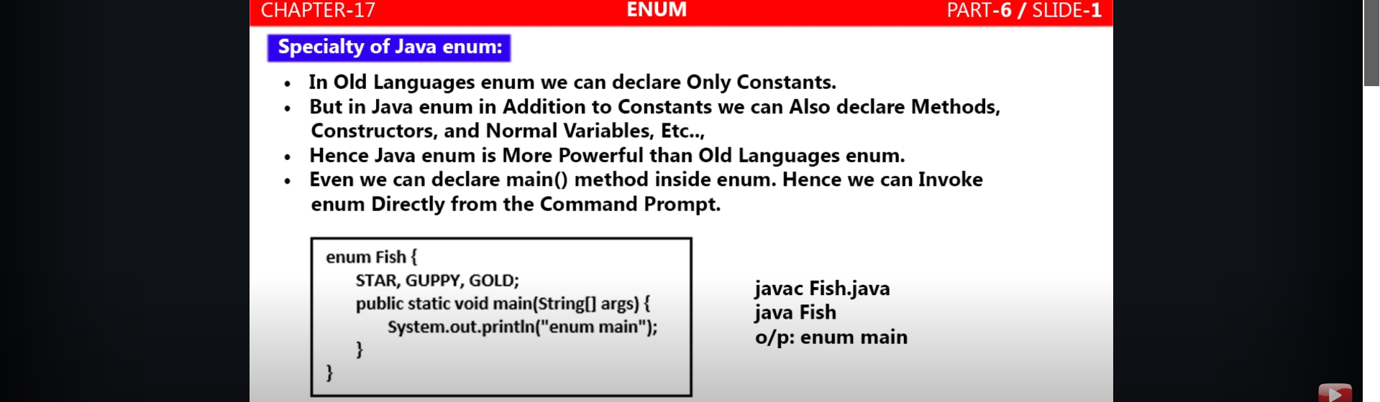  
     
     
     
   
3. Inside enum, we can declare main() and we can run from Command prompt.
   1. **Some observations**:
      1. Semicolon after constants mandatory when enum having any other member like method, normal variable.
      2. If no enum constant but any member, then semicolon is required.
      3. In case of any extra member, the 1st line must start enum constants terminated by semicolon.
      4. In case of any extra member but no constant, then just semicolon.
      5. Enum without any constant and members, it is valid but useless.